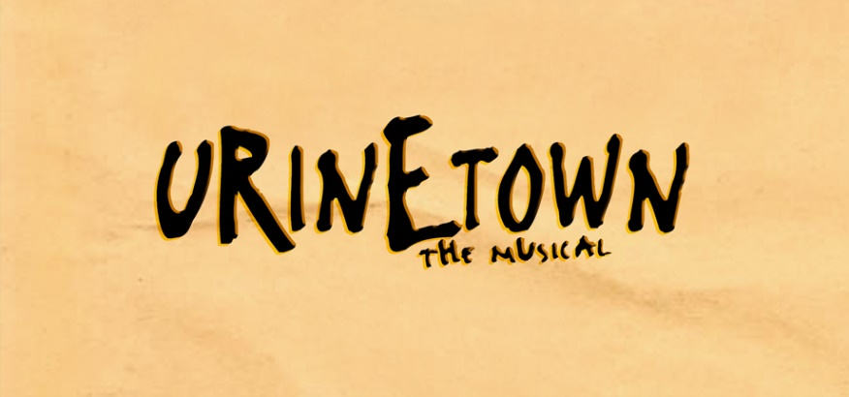
GHS 2023 AUDITION PACK

Important Audition Dates
----------------------------------------------------------------------------------------------------------------
Dance/Vocal Audition
(All students)
Tuesday 7th of February (Week 2)
3:30pm – 5:00pm
Hall
Lead Audition
(Lead role auditions only)
Thursday the 9th of February (Week 2)
From 3:30pm
Music Tech
Sign up for lead role audition here: https://forms.gle/UonLvZLxQTYQ6gw17

Who Can Audition?
----------------------------------------------------------------------------------------------------------------
All students from year 7 through to year 12 can audition. All students will get into the production if they have attended an audition. Students in Year 7 can only audition for the following character roles:
- Little Sally
- Officer Barrel

For more information, please refer to compass and/or contact Ms. Tessa Kirk: Tessa.kirk@education.vic.gov.au

