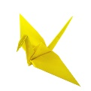
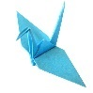

During Term 1 we have had lots of students folding Peace Cranes with a focus for wishing for Peace in the Ukraine. Thanks to the wonderful folding efforts of Isabella, Sam, Rae, Nawal and Amelie (and many others) we reached our goal of folding 1,000 paper cranes by the end of Term One – well done! The finished cranes will be sent to the The Children's Peace Monument at the Hiroshima Peace Memorial Park in Hiroshima, Japan

We have had a wonderful time displaying Year 8 and Year 10 student artwork this term, many thanks to Miss Veenstra and her talented Studio Artists!

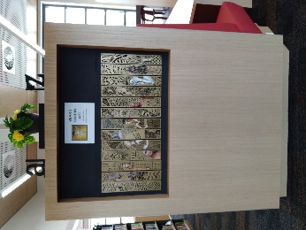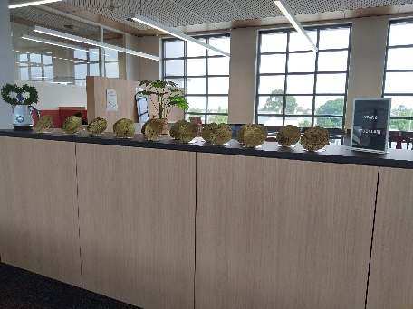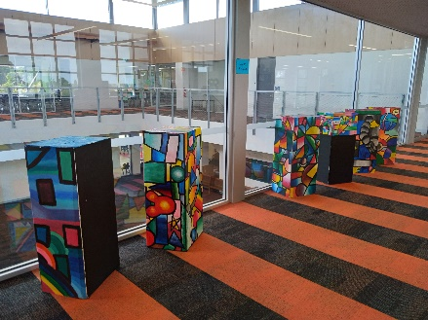

We’d like to take this opportunity to wish all our Geelong High School Community families a safe and happy holidays and may we all come back to Term 2 feeling refreshed and ready for the rest of the year!

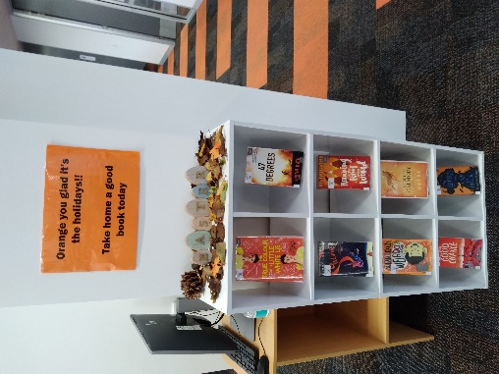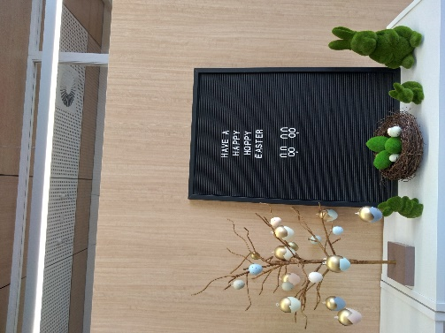

Keep reading over the holidays – it is a wonderful way to keep your mind active!
Visit your local Geelong Regional Library branch to explore a world of reading (and lots of activities for all the family). Visit https://www.grlc.vic.gov.au/ to find your local branch Library.
Explore the Holiday activities for children of all ages in their latest on-line brochure:
https://www.grlc.vic.gov.au/whats-brochure

Did you know?
Your Geelong Regional Library Membership allows you access to an amazing array of on-line magazines (from gaming to lifestyle, for pet lovers and for more studious types).
Libby Magazines
‘The friendly way to read magazines! Libby allows you to explore over 3000 digital magazines and flip through like a real magazine. This is free and easy way to access to the most recent editions; no waiting in queues; no struggling with interface. Use the Libby App or access from a web browser.’
https://geelongvic.overdrive.com/

